***Tottenham Health Fair***

**Venue: Former John Loughborough School, N17 9AD.**

**Date: May 24th  - 31st 2015**

.

**YOUR LIFE ~ YOUR HEALTH**





**Seventh–day Adventist Church**

**Restoration and Beyond**

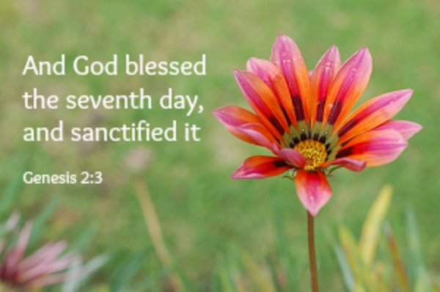



**Sunset Times**

**15th  May 8:45pm**

**22nd May 8:56pm**

**29th May 9:05pm**

**05th June 9:12pm**

**Sabbath 16th May 2015**

**LET’S CELEBRATE MAY’S BIRTHDAYS**

**5th Chelsea Charles**

**23rd Lawanda Mansukani**

**23rd Reeon Tyser**

**24th Marcia Gayle**

**24th Vivian Maxwell**

**27th Raymond Gayle**

**29th Carol McGeary**

**I desire a pastoral contact:**

**253-255 West Green Road**

**Tottenham, London**

**N15 5EG**

**Tel: 0208 802 1477 / Mobile: 07984270491**

**Email:** [**Tottenhamsda@hotmail.com**](mailto:Tottenhamsda@hotmail.com)

**Web:** [**www.tottenham.adventistchurch.org.uk**](http://www.tottenham.adventistchurch.org.uk)

Name:

Address:

Telephone:

Email:

**FOLLOW US ON**

**Church Prayer Lines**

**If you need someone to pray with you, please call any one of the following prayer lines:**

**07984270491 or 0208 802 1477**

**The above person..... I Wish to.....**

□Is ill □Have Bible studies

□Is a visitor □Be baptised

□Has a new address □ Transfer membership to this church

□Desires a Pastoral Visit

**Our Pastor would like to help you.** If you have a need, please feel free to contact him using the contact details above (You can place this slip in an offering basket or give it to one of the ushers at the door or an Elder)

**Pastoral Contact**

Pastor Valentine Roach Tel: 07792 648 534 Email:valagusroach@yahoo.co.uk

**Let Us Pray 9:00AM**

**Sabbath School 9:30am**

**Jesus, The Holy Spirit and Prayer – Lesson 7**

|  |  |  |
| --- | --- | --- |
| Opening Remarks |  | Sis K Birch |
| Opening Hymn |  | Sis K Birch |
| Scripture Reading |  | Bro D Grant |
| Prayer |  | Sis K Birch |
|  | **Lesson Study** |  |
| Welcome |  | Sis K Birch |
| Special Item |  | Sis P Riley |
| Closing Remarks |  | Sis K Birch |
| Ten Minute Spot |  | Bro V Maxwell |
| Closing Prayer |  | Sis V Wright |

***“So I say to you, ask, and it will be given to you, seek, and you will find; knock, and it will be opened to you. For everyone who asks receives, and he who seeks finds, and to him who knocks it will be opened” (Luke 11:9.10 NKJV)***

**Divine Service 11:00am**

|  |  |  |
| --- | --- | --- |
| Song Service |  | Praise Team |
| Call to Worship |  | Sis H Campbell |
| Invocatory Prayer |  | Elder R Charles |
| Opening Hymn | **Hymn No**.**27** | Praise Team |
| Announcements |  | Church Clerk |
| Welcome |  | Sis C Reid |
| Children’s Story | **Nathaniel Awotwi** | Sis H Campbell |
| Tithes & Offering |  | Bro B Reid |
| Scripture Reading |  |  |
| Pastoral Prayer |  | Bro B Morris |
| Meditational | **Teens Group** | Bro R Reid |
| Sermon | **“Like A Tree”** | **Elder R Charles** |
| Closing Hymn | **Hymn No.316** | Praise Team |
| Benediction |  | Elder R Charles |

**After service, please remain seated.**

**The ushers will lead you out of your seats reverently, and quietly.**

**Tottenham Pathfinders Street March** – **TODAY** **at 3pm**

**Volunteers needed to help out, please see Sis Andrea Reid if you are willing to help.**

**ANNOUNCEMENTS**

**This Week**

**BULLETIN SUBMISSIONS:** Please email to: [**Tottenhamsda@hotmail.com**](mailto:Tottenhamsda@hotmail.com)

**by: 6:00pm on Tuesdays**

**Skill Audit**: The Communication department recently conducted a SKILL AUDIT of members and regular visitor, if you haven’t completed one of these forms, please see one of the team.

**Nepal Appeal!** Help urgently needed. Death toll over 8,000, more than 70% of homes damaged. We will be collecting in the month of May to help. Fast action is critical.

**ADRA UK TINS** - Please bring in all your tins for counting.

**Doxologies**. Please note that the Doxologies will be changing from **TODAY**, May 16th 2015

**Men’s Ministries** - Barry would like all the men to meet after the mid-day service for 10-15 minutes so that you all can pray over the prayer scroll.

**Tottenham Pathfinders Street** **March** – **TODAY** 16th May. At 3pm. Volunteer needed to help out, please see Sis Andrea Reid if you are willing to help.

**Dates for your Diaries**

**Special Prayer Meeting** – 20th May – If you have specific prayer requests for someone who is sick, a student who is taking exams, a family member who has left Jesus and you want them to return, please give names to Sonia Munroe before 17th May.

**Montserrat Day of Fellowship** – 23rd May 2015 9.3 0- 5.30pm, The Conference Centre, 70 Thomas Street Aston, Birmingham. A Centenary Celebration of Adventism in Montserrat, the 15th Day of Fellowship, Guest speaker Ps J Wilmoth James from the United States Virgin Islands.

**Music Day** - 6th June, followed by an evening of praise, worship and testimonies. Featuring: Kimberly Bulgin, Hampstead Adventist Choral Society, 3IHN and our home groups, soloists, choirs and musicians!! Invite your friends and family for a day of music, adoration and worship. Lunch will be provided.  

**SEC Child Protection Training** – Sunday 7th June 2015, 10am - 4pm at the Advent Centre.

All heads of department should attend. This is a free course put on by the SEC department.

**SEC Camp Meeting** -June 15th -21st 2015. [campmeeting@secadventist.org.uk](mailto:campmeeting@secadventist.org.uk). Weekend forms available

**Tottenham West Green Road** **Men’s Ministries Department** cordially invites you to their Men’s Ministries Weekend planned for 21-23 August 2015, with the President Pastor Ian Sweeney.

**Hyland House**: **90 Years of Educational Excellence** – 18th July 2015, 10.30- 8pm. Walthamstow Town Hall. E17 6HE

**Harvest** – will be on the 29th August 2015.

**Prayer & Faith Conference** – 26-30th October 2015, £75 per person, venue to be decided.

**Remember Them in Your Prayers**

Eld & Sis Baxter Snr Bro & Sis Josiah Sis B. Amartey

Sis L. Beckford Sis N. Sinclair Sis E. Silcott Sis A. Sithole Sis Marcia Gayle Sis M. Graham

Bro T Joseph Sis Valerie Strachan (Mourning the death of her brother)

Sis Hannah Obeng- Badu (Mourning the death of her father)

**Prayer Meeting is held HERE every Tuesday 12:00 noon and Wednesdays at 8pm.**

**Wednesday night meeting this week summarizing: ‘The Adventist Home’**

**Adventist Youth Service at**

**5pm**

**Bible Class**

**4pm**