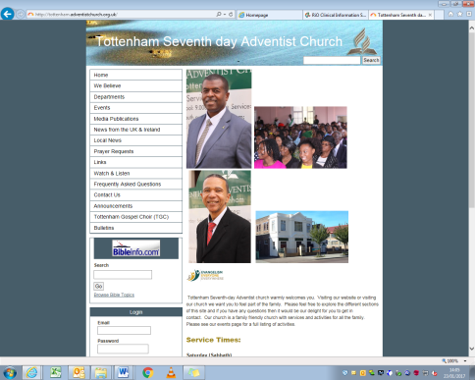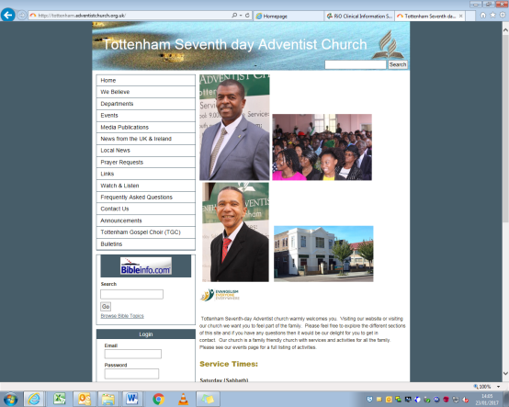 1

|  |  |  |
| --- | --- | --- |
| Church DIRECTORY | | |
| **Pastor:** Dr Jude Jeanville  Tel: 07561 896 711  jude.m.jeanville@gmail.com  Open Surgery: Wed 11am – 8pm  *Please ring to book an appointment*  **First Elder:** Roger Charles  Tel: 07961 931 917  rogercharles2000@hotmail.com    **Church Clerk:** Stacey Marshall  Tel: 07957 591 294  stacey.marshall@blueyonder.co.uk  **Head Deacon:** Earl Grant  Tel: 07859 050 963 | | |
| May - Happy Birthday to you! | |
| 01 Kadrina Onyemenem  05 Chelsea Charles  10 Deborah Apeah-Kubi  20 Carman Leslie  21 Carol McGeary | 23 Lawanda Mansukani  23 Reeon Tyser  24 Vivian Maxwell  27 Raymond Gayle |

We welcome you today to our service and our visiting Evangelist, Pastor Terry Alva John, Vice President and Senior Pastor of the University of the Southern Caribbean.

**Sabbath 6 May 2017**

**Welcome**



Remember Them in PRAYER

Sis L Beckford (Stamford Nursing Home)

Sis N Sinclair (Wakefield Rd Care Home)

Sis L Richards (Wakefield Rd Care Home)

Sis S Josiah (Morriss House, Crouch End)

Bro B Riley (Wakefield Rd Care Home

Sis M Silcott Sis A Sithole

Sis N McFee Sis M Gayle

Sis Sherrington Bro T Joseph

Sis B Amartey Sis Robinson

Bro M Bucknor Sis N Bravo

Sis D Clarke Sis E Ifill

**Seventh-day Adventist Church**

Church at prayer

Prayer Line - 020 8802 1477

Prayer Meeting - Tuesday 12 noon

Prayer Meeting - Wednesday 8pm

Tottenham

**Evangelistic series- "Metamorphosis" Final Day**

1. I will care for my body as God's temple.   
2. I will pray at least once daily for the Holy Spirit to be poured out on our church and community.  
3. I will pray especially for the Evangelist's health an inspiration.  
4. I will pray for good weather.  
5. I will pray that the Holy Spirit will work miraculously through the church's public witness on The Green to meet the needs of people.  
6. I will be intentional about encouraging someone to stop by and be blessed.  
7. I will personally make a sacrifice to attend.

|  |  |
| --- | --- |
| CONTACT / Watch & Follow us | |
| 253-255 West Green Road, London N15 5EG | |
| **Telephone** | 020 8802 1477 |
| **Email** | Tottenhamsda@hotmail.com |
| **Facebook** | Tottenhamsda Westgreen |
| **YouTube** | Tottenham sda church |
| www.tottenham.adventistchurch.org.uk | |

**A**nnouncements

**BULLETIN SUBMISSIONS:** Please email to: [**Tottenhamsda@hotmail.com**](mailto:Tottenhamsda@hotmail.com) **By: 6:00pm on Tuesdays**

* **Church Info:** To receive information about what is happening at Tottenham SDA Church, send details to **07914 966 387.**
* **Streaming:** The Service is streamed every Sabbath.
* **Baptism:** Today
* **Tottenham Visitors’ Day: 13 May**
* **Religious Liberty & The New British Bill of Rights.** **14 May**,

10-1pm at The Advent Centre. WIH 5JE

* **Stanborough Doors Open:** You are invited to tour the secondary school on **21 May** from 11am to 1pm. Stanborough Park, Watford WD25 9JT
* **Pathfinder Curriculum Camp: 26 - 29 May**. Please remember to clear outstanding balances.
* **Montserratians and friends SDA Day of Fellowship**. **27 May**. Whalley Range Methodist Church. Manchester M16 8FA
* **Your Life Your Health –** health expo is being held on **27-29May** (both in church and across the Green).Health checks, talks and bouncy castles will be available. If you would like to set up a stall, please contact Bro Maxwell or Sis Grant.
* **June 3** - **Music Day** at Tottenham SDA church with Guest Speaker Jillian Monet also featuring: Lois Moodie, violinist Nicholas Peat, London Ghana Harmonies, Scripture Says Acappella, The Lord's Instruments,
* **Camp Meeting: 19 -25 June** Pontin’s, Prestatyn, Wales
* **Kidz Festival of Praise 8 July**  9.15-4.30. House on the Rock.
* **Womens Health Day. 16 July** 12-5pm Entry fee £1., Haringey Irish Center. Pretoria Road N17 8DX
* **All London Sports Day - 30 July .** 11am – 6.30pm. Lee Valley Athletic Centre.N9 0AR
* **Church Building Fundraising Concert:**  **September 16** hosted by Natasha Riley featuring all home acts and the Filipino Church Choir: Speaker Dr Jude Jeanville. Theme: My Father's House.
* **International Day:** **October 14** - featuring: The Male Voice choir, Levites, Peggy and Co, Testify, and many more. Theme: "Are We There Yet? Looking For A City!"

Divine Service – **10.50am – 12.45pm**

Introit Praise Team

Call to Worship Bro J Baxter

Invocatory Prayer Pastor T John

Welcome Sis M Wadibia

Song Service Praise Team

Opening Hymn  Praise Team

Prayer Garden Bro R Reid

Scripture Reading Pastor T John

Tithes and Offering Bro C Humphrey

Children’s Story  **Sis S Rodgers**  Bro J Baxter

Meditational Bro R Reid

**The Kings Men**

Sermon Pastor T John

Closing Hymn Sis M Wadibia

Benediction Pastor T John

Please be mindful of where your children are at

**ALL TIMES** and ensure that they are supervised especially when they use the toilet facilities.

**After the service please remain seated.**

**The Ushers will lead you out**

**reverently and quietly.**

**S**abbath **S**chool **9.30am – 10:45am**

# Lesson 6:- *Suffering For Christ*

“For to this you were called, because Christ also suffered for us, leaving us an example, that you should follow His steps” (1 Peter 2:21, NKJV).

Opening Remarks Sis K Birch

Opening Hymn Sis K Birch

Opening Prayer Sis Bowen

Scripture Reading Sis K Birch

**Lesson Study**

Welcome Sis M Pollock

Special Item Sis J Thorpe

Closing Remarks Sis K Birch

**10 Min Spot**

Closing Prayer Bro D Knight

***5 minute intermission***

***Announcements Church Clerk***

Today’s Meetings

Baptism – This afternoon

SUNSET Times

05 May – 20:34 12 May – 20:45

19 May – 20:56

**On Duty This Month**

Deacon: Bro Clive Humphrey

First Aider: Sis Doreen Williams

**Church Directory**

[](http://www.google.co.uk/url?sa=i&rct=j&q=&esrc=s&source=images&cd=&cad=rja&uact=8&ved=0ahUKEwj6k9zMvJrMAhWD0RQKHQJ6Ad8QjRwIBw&url=http://adventist.org.uk/news/news-archive/buc/newbold-alumnus-jude-jeanville-joins-recruitment-team&psig=AFQjCNEVwMHv_8aF1llObUiXkQILdW9BpA&ust=1461147459736492)



Church Clerk:

Head Deacon: Clive Humphrey

Tel: 07957743689

First Elder Roger Charles

Tel: 07961 931 917

Email: rogercharles2000@hotmail.com

On Duty THIS MONTH

Elders: Orville Baxter & Orthan Brown

Deacon: Earl Grant

First Aiders: Carmelita Knight & Courtney Reid

**Bible Class**

**4.00pm**

**On Duty This Month**

Deacon: Bro Clive Humphrey

First Aider: Sis Doreen Williams

**Church Directory**

[](http://www.google.co.uk/url?sa=i&rct=j&q=&esrc=s&source=images&cd=&cad=rja&uact=8&ved=0ahUKEwj6k9zMvJrMAhWD0RQKHQJ6Ad8QjRwIBw&url=http://adventist.org.uk/news/news-archive/buc/newbold-alumnus-jude-jeanville-joins-recruitment-team&psig=AFQjCNEVwMHv_8aF1llObUiXkQILdW9BpA&ust=1461147459736492)



Church Clerk:

Head Deacon: Clive Humphrey

Tel: 07957743689

First Elder Roger Charles

Tel: 07961 931 917

Email: rogercharles2000@hotmail.com